What is LangGraph?

LangGraph is an orchestration framework for building intelligent, stateful, and multi-step LLM workflows.
It enables advanced features like parallelism, loops, branching, memory, and resumability - making it ideal
for agentic and production-grade Al applications.
It models your logic as a graph of nodes (tasks) and edges (routing) instead of a linear chain.

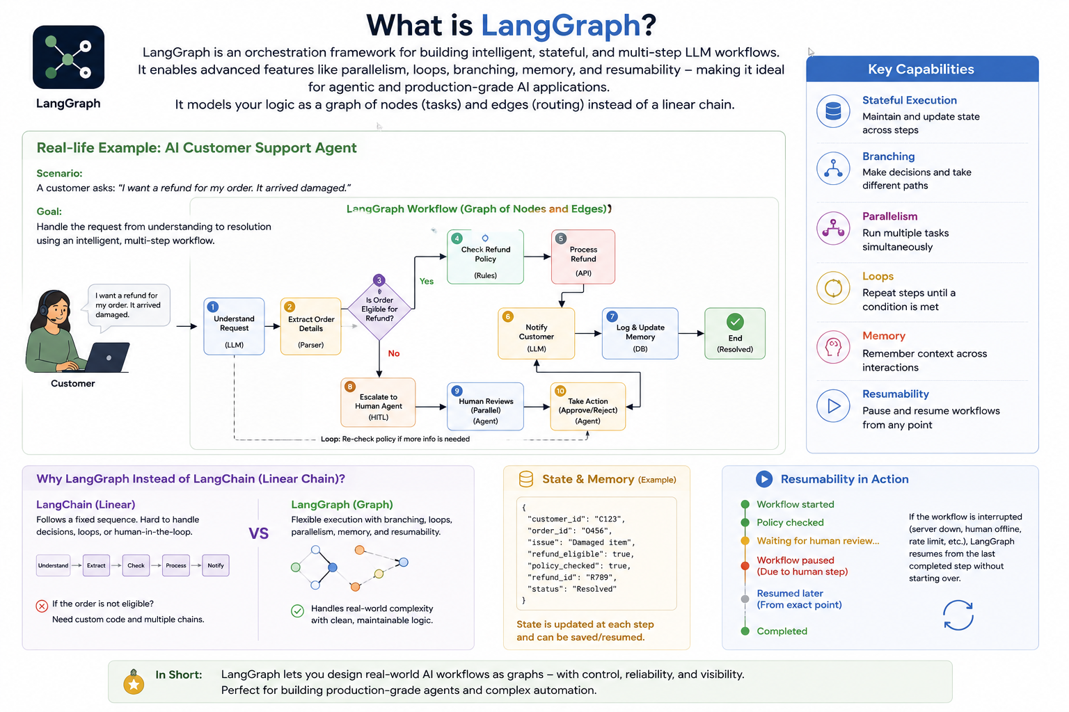

LLM Workflows:

1. LLM workflows are a step by step process using which we can build complex LLM applications.
2. Each step in a workflow performs a distinct task - such as prompting, reasoning, tool calling,
memory access, or decision-making.
3. Workflows can be linear, parallel, branched, or looped, allowing for complex behaviours like
retries, multi-agent communication, or tool-augmented reasoning.
4. Common workflows

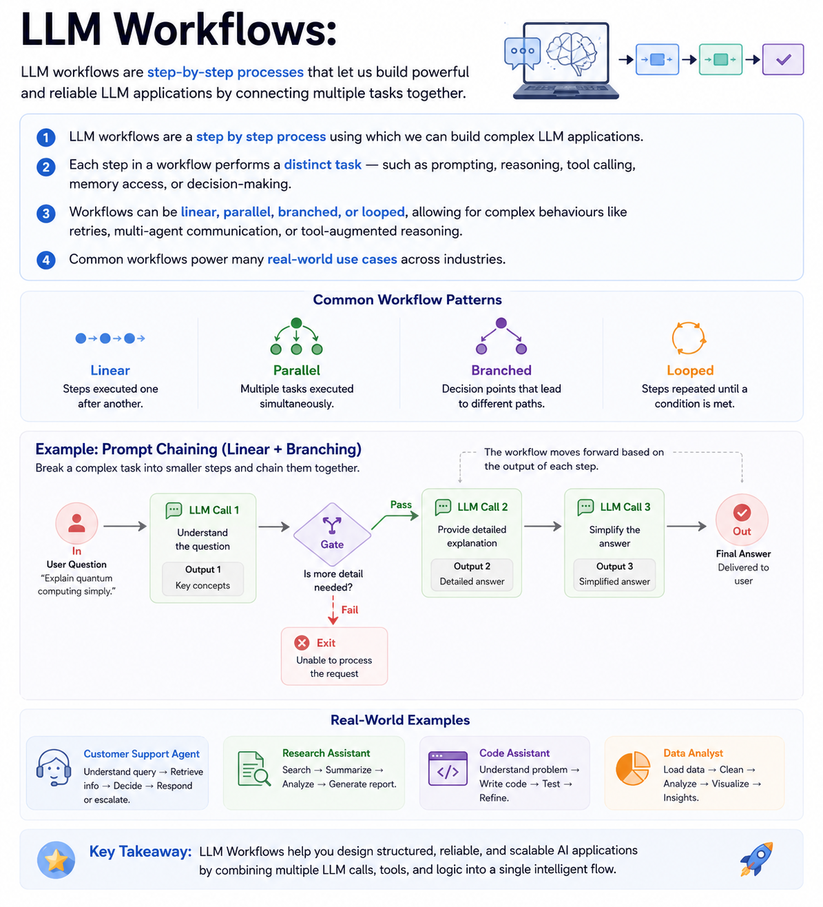

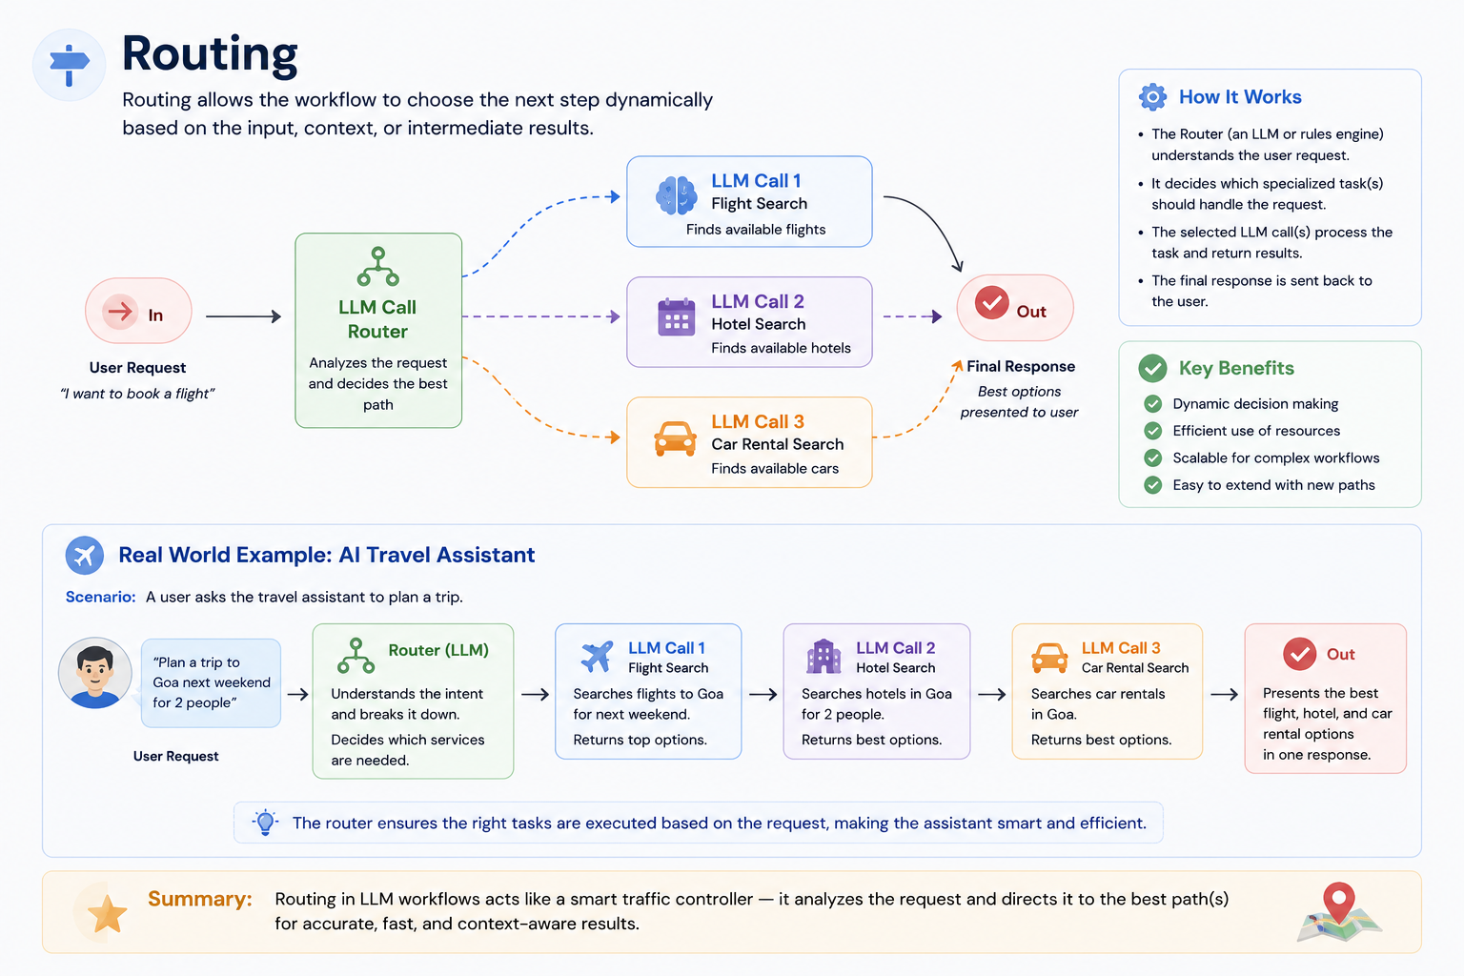

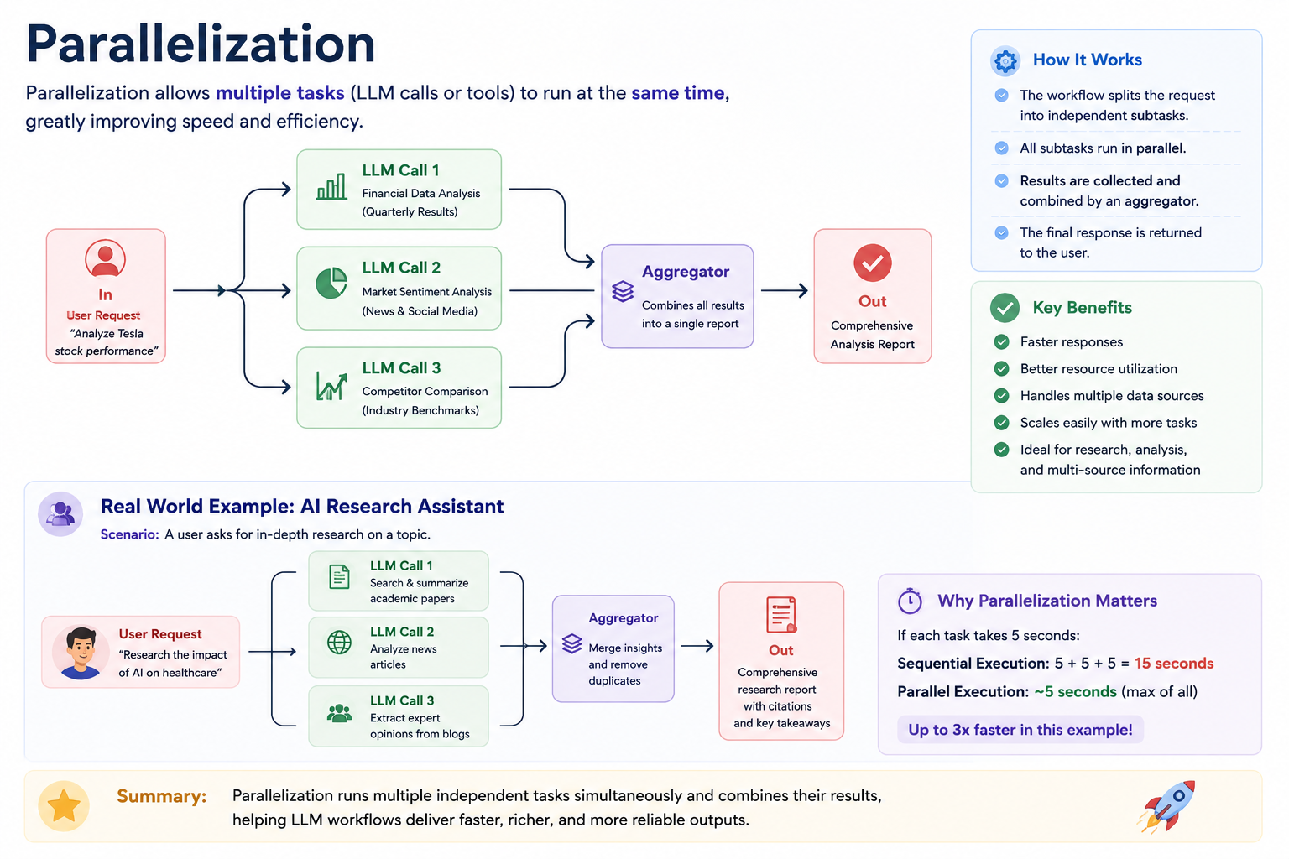

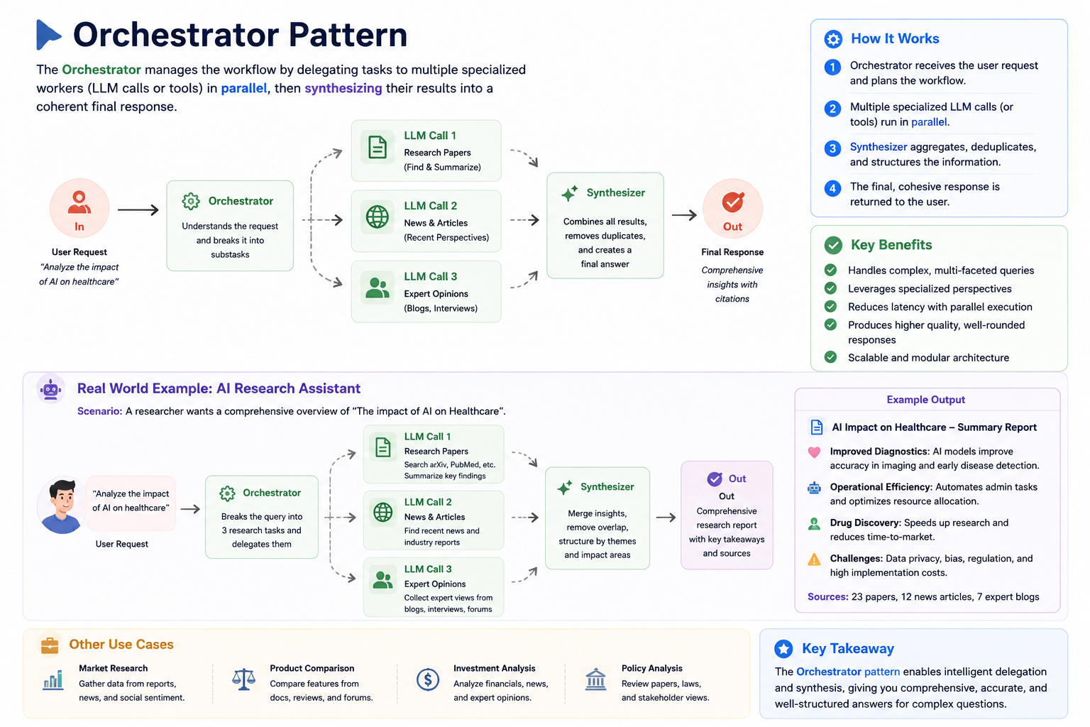

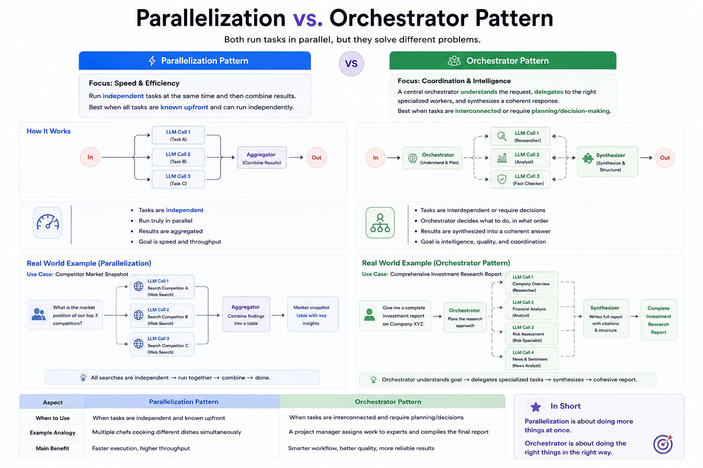

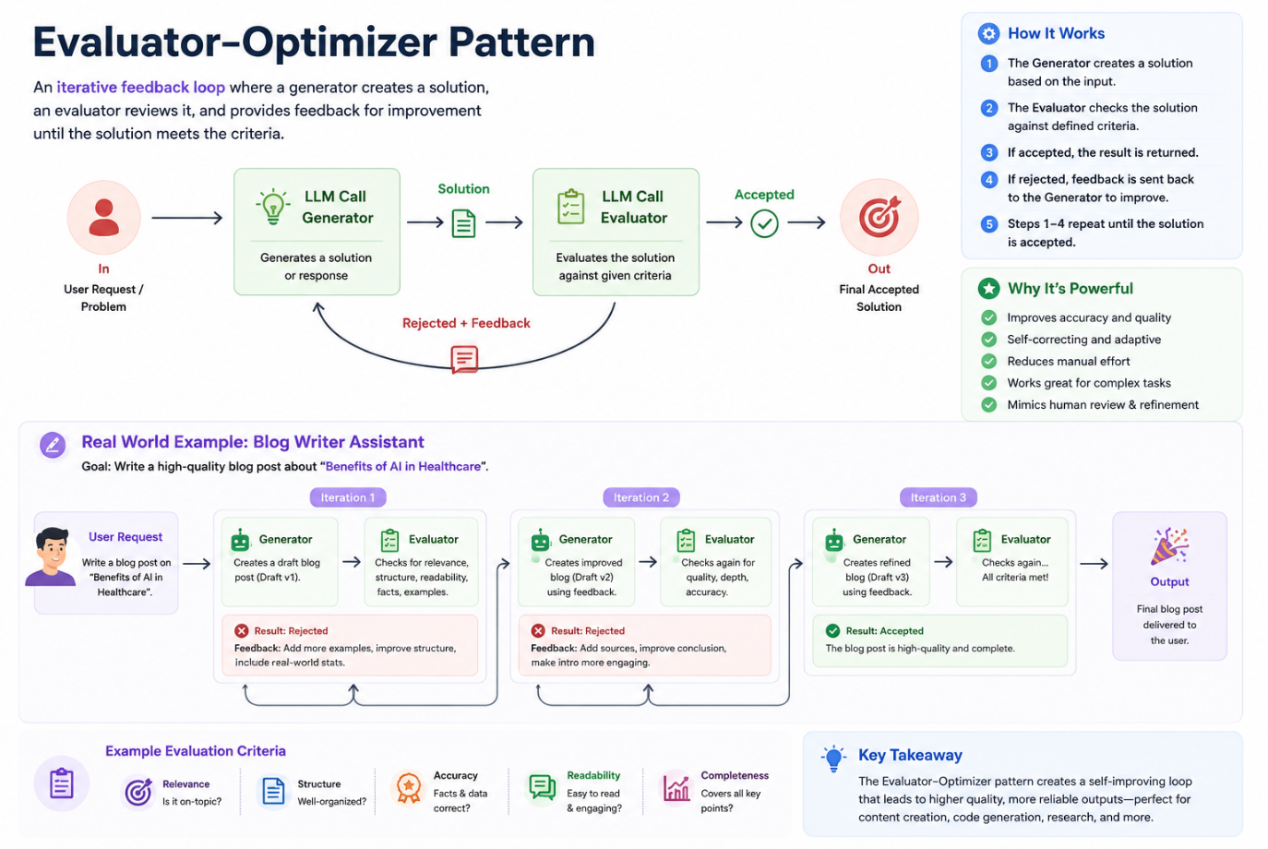

Graphs, Nodes & Edges:
The system generates an essay topic, collects the student's submission, and evaluates it in parallel on depth of analysis, language quality, and clarity of thought. Based on the combined score, it either gives feedback for improvement or approves the essay.
1. GenerateTopic
+ System generates a relevant UPSC-style essay topic and presents it to the student.

2. CollectEssay
+ Student writes and submits the essay based on the generated topic.

3. EvaluateEssay (Parallel Evaluation Block)
+ Three evaluation tasks run in parallel:
. EvaluateDepth - Analyzes depth of analysis, argument strength, and critical thinking.
. EvaluateLanguage - Checks grammar, vocabulary, fluency, and tone.
. EvaluateClarity - Assesses coherence, logical flow, and clarity of thought.

4. AggregateResults
+ Combines the three scores and generates a total score (e.g., out of 15).
5. ConditionalRouting
+ Based on the total score:
. If score meets threshold + go to ShowSuccess
. If score is below threshold + go to GiveFeedback

6. GiveFeedback
+ Provides targeted suggestions for improvement in weak areas.

7. CollectRevision (optional loop)
Student resubmits the revised essay.
+ Loop back to EvaluateEssay

8. ShowSuccess
+ Congratulates the student and ends the flow.

